Practice 360° - CDM Toolset.
Version History
Version # | Date | Author | Key Differences

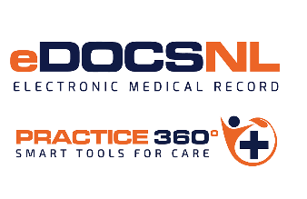 | Project Change Request (CR)
Change Request Submission Section
Change Request Title: |  |  | CR Number: (CRC Use Only)
Originator Name | [Name] | Originator Organization | [Organization name]
Date Submitted | [XX/XX/XXXX] | Originator’s Manager | [Manager name]
Primary Contact Person | [Name] | Backup Contact Person | [Name]
Primary Contact E-mail | [E-mail] | Backup Contact E-mail | [E-Mail]
Detailed Description of Proposed Change
Justification for Change
Current Workaround (if applicable)
Potential Cost Considerations
(if known)
Additional Information / Comments
Signature | Signature: _____________________________________________  Date: ____________________

